Shopping Cart

Presentation Layer
Let’s start by running through the shopping cart demo in action so that we can see what it does...
Here is the use case diagram for the demo.
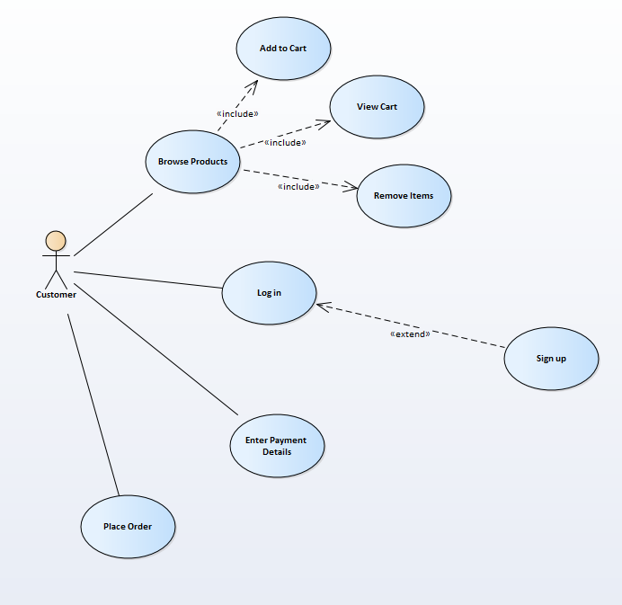
The important thing to appreciate with the shopping cart that it is not a representation of the order; it is in fact a representation of the member of staff taking an order over the phone.
Imagine rather than building the order on-line you actually ring in to place your order.
What would happen is that a person sitting at a desk would take exactly the same role as the shopping cart.
- This person would do the following...
- Take the details of the items that you wanted to buy
- Amend these details depending on stock availability or you changing your mind/making mistakes.
- Take your name and address details, perhaps setting you up with an account on the system
- Take payment details
- Confirm the final order is correct
- Create the order
The person you are talking to may have a less than easy to use order entry screen like so...
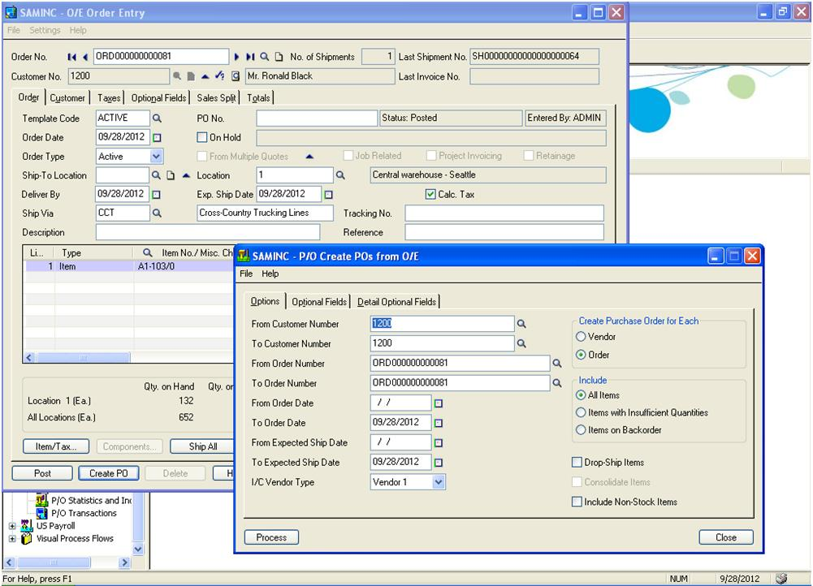
It is important to appreciate that the complexity of a screen like this doesn’t matter to the person using the system.
This person is an expert user who accesses this screen frequently each day.
You wouldn’t present a novice user with this screen as it would be too complex.
For anybody handling order entry it is best to think of your part of the system initially from the POV of the backend rather than a shopping cart. You are likely as not to create a method called AddOrder which accepts all of the order details.

The Middle Layer Code
Let’s take a look at the class diagram...
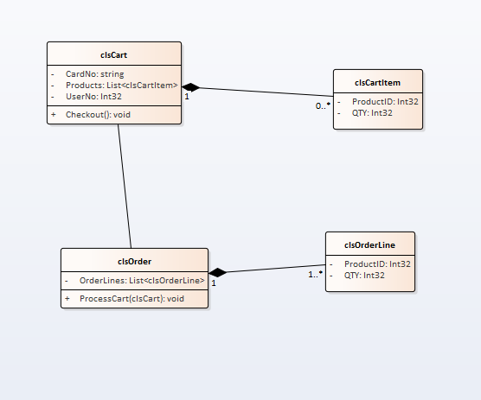
Notice that the cart classes exist separate from the order classes.
Once the cart has done its job it needs to be passed to a method in the class clsOrder for processing.

Data Layer
From the POV of the shopping cart there is no data layer!
The shopping cart is a tool that only exists in ram for the placing of the order.
In this example we persist the class using the session object, in a real implementation it would likely use cookies, why?
Whenever we place data into the session object it sends information from client to server. This adds extra processing at the server, coupled with the data transmission slows the whole process down.
Storing the data as a cookie on the client means that the data remains only on the client machine and is only sent to the server once the order is to be processed.
For clarity and simplicity this example uses the session object, but not the best choice really.

Bringing it all Together

Browse Products
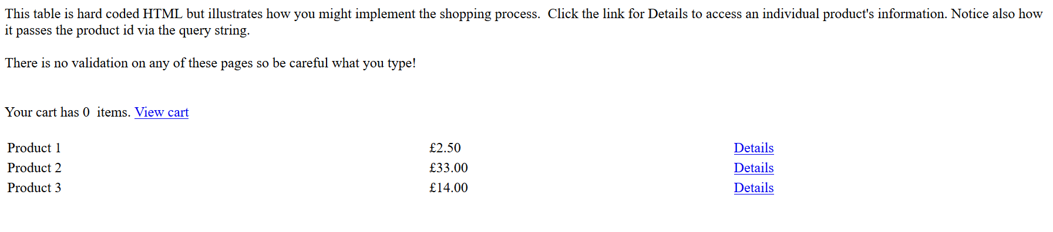
Notice the Load and Unload events for the page...
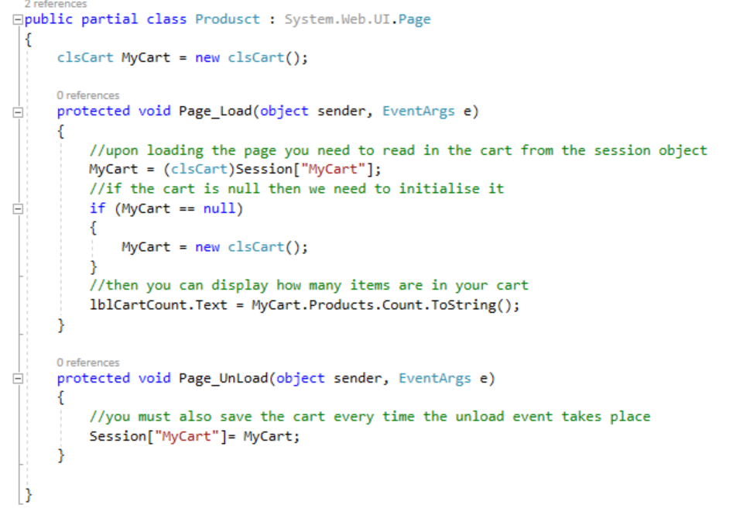

View Details
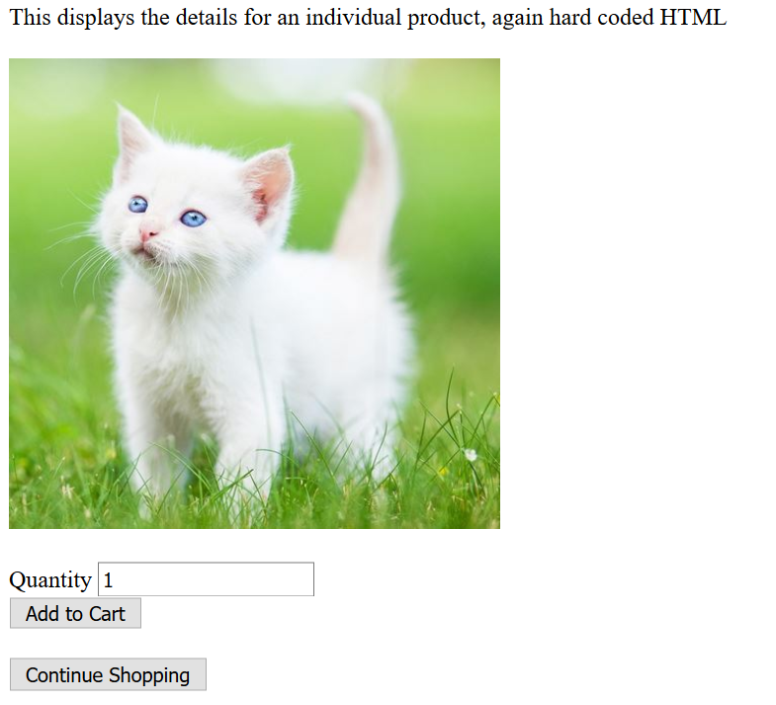

Add to Cart
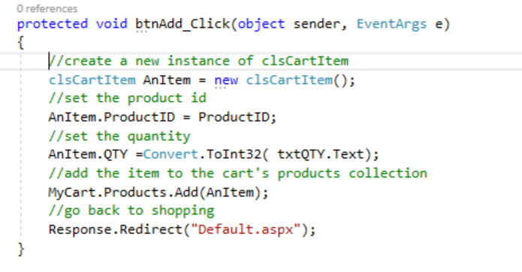
Notice the Load and Unload Events for each page...
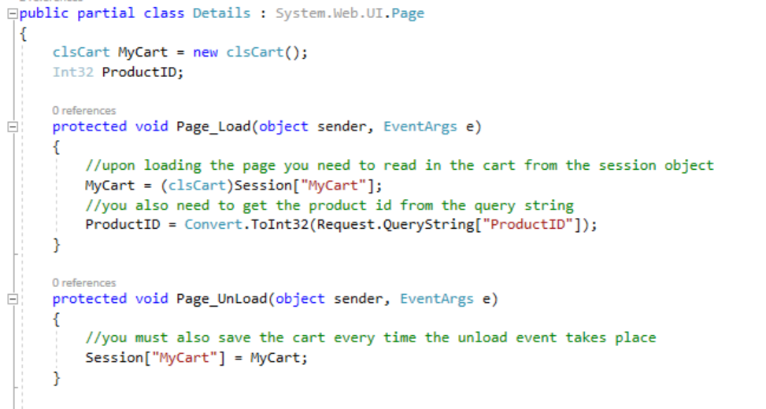

View Cart
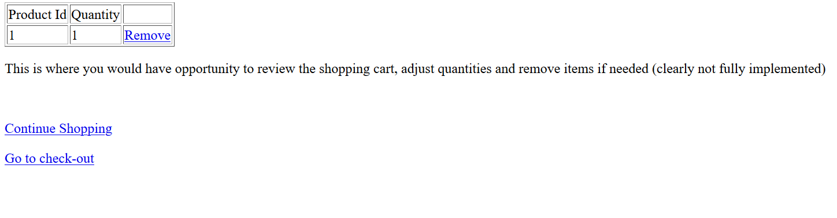
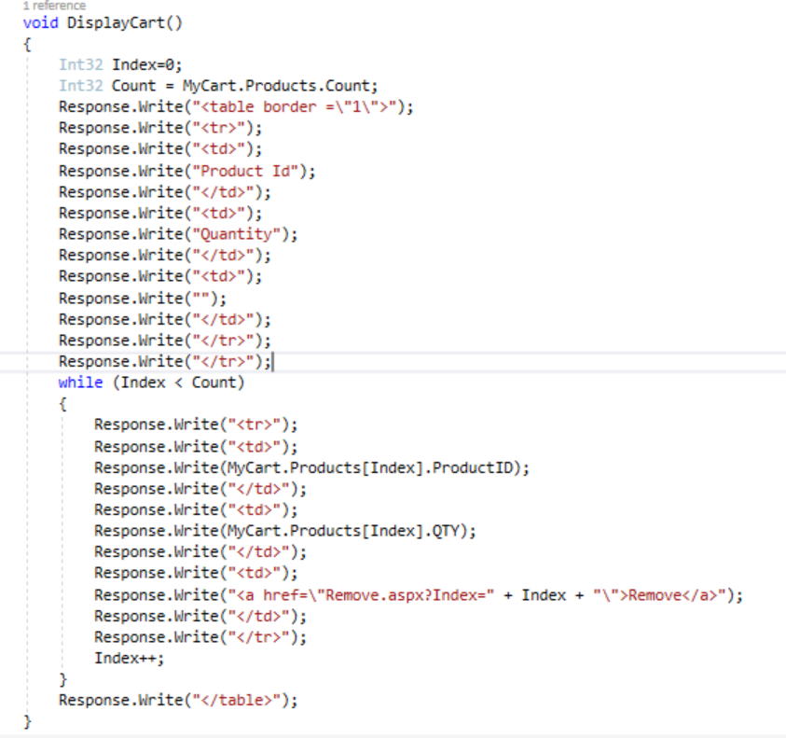

Go to check-out/Login
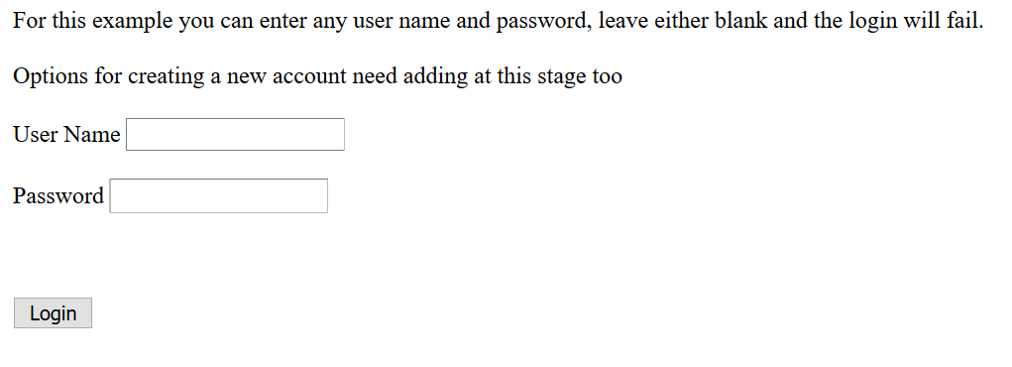
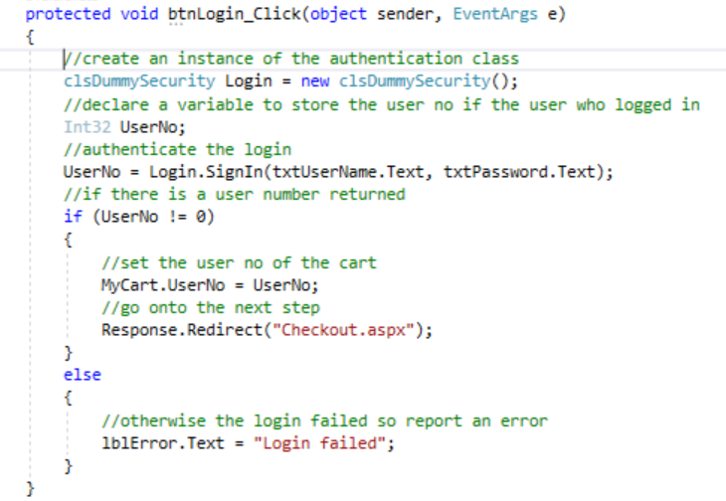

Enter Payment Details
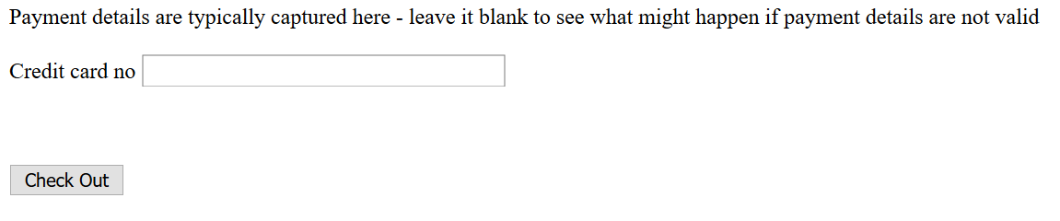
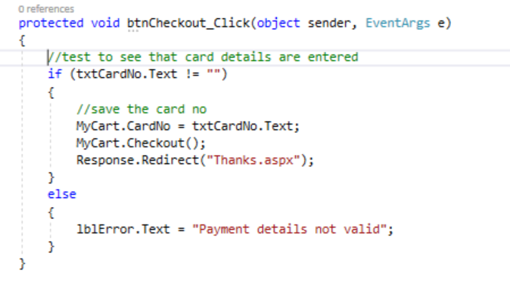
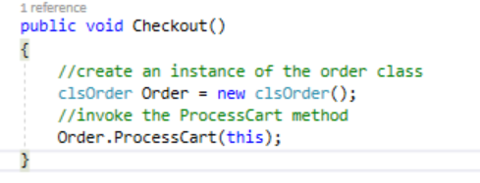
Note the use of “this” as a parameter!

ProcessCart Method
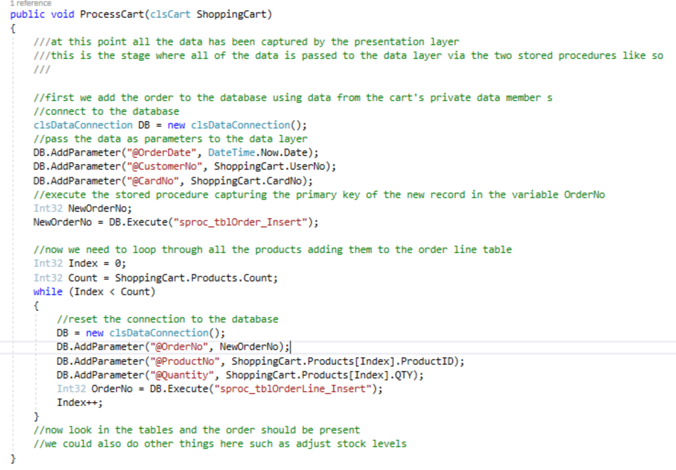

Two Stored Procedures
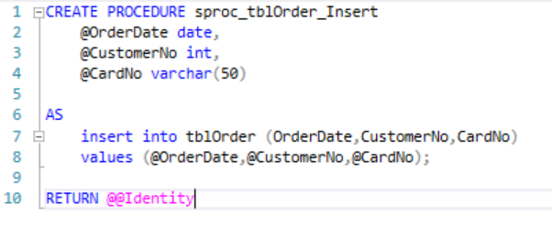
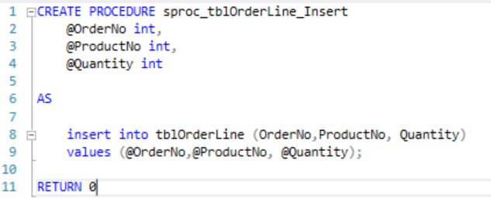

Two Tables
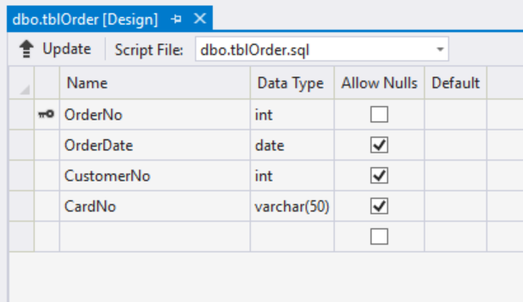
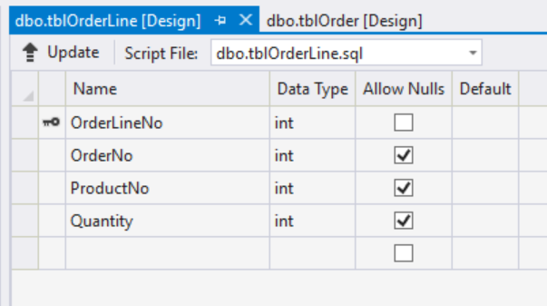

Finally
This is clearly a limited implementation of a shopping cart, there is plenty more to be done, however there is plenty her to allow you to get the basics in place and extend as required from there.

